Cleaning Up Your Computer
By David L. Lawrence, RFC®, AIF®

Year-end is often a good time to work on cleaning things up. Your office clutter is one issue, clutter on your computer quite another. We all do it. We add programs, applets, files, free program demos and other items that often deposit electronic clutter on our computers without realizing it. This clutter can be nothing more than a nuisance or it could lead to some serious problems, such as unwanted or malware, Trojan viruses, or other potentially harmful content. Less harmful, but just as worrisome is the addition of line items to the computer’s systems registry. While this could mean nothing, what also could mean is a slow-down in performance (at the very least) as your computer is asked to wade through all this unnecessary programming code to find what it is looking for. Often the result is sluggish performance.
Practically everything you do in Windows is recorded somewhere in the Registry. The paths to the last dozen or so images or documents you opened are there, too, as are the details of the programs you most recently installed or uninstalled.
Here's the problem: If you pry open the Registry, you'll probably find it about as cluttered as your office. That's because Windows doesn't efficiently clean up after itself as it goes about its daily business. It constantly creates new entries, but seldom--if ever--removes them after they're no longer needed.
Compounding that problem are applications that are too inept to uninstall all of the Registry entries they create; far too often, program upgrades and installers leave unneeded pointers in the Registry. So the Registry becomes bloated with unnecessary entries, slowing down your system.
But, before working on the registry, you may want to look at the amount of fragmentation you have on your hard drive(s). To do this in Windows XP (or Vista), click on
Start | Programs | Accessories | System Tools | Disk Defragmenter. This little program included in Windows can help determine if your computer slowdown is the result of fragmentation or something else. If fragmentation is less than 10%, chances are a system slowdown is not caused by fragmented files. Therefore, it may be necessary to look at what is currently running on your computer and to analyze the registry.
To look at what is running, there is a nifty little program called What’s Running (www.whatsrunning.net). What’s Running is a free program that can analyze what is actually running in the way of software and/or applets on your computer at the moment. This little program may open your eyes to just how much clutter there is on your computer. And, it offers a way to clean up much of this clutter. As an example, a recent look at What’s running on my computer revealed this screen shot showing 96 processes running, 131 services, 920 modules, 68 IP Connections, 232 Drivers and 63 Startup items.
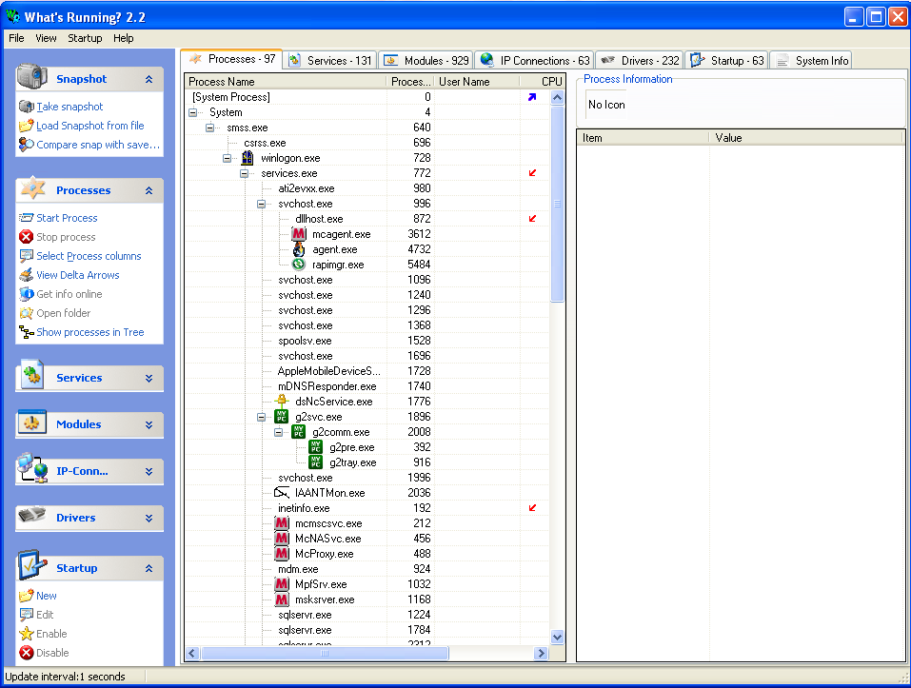
And while this is a frighteningly large list, it is not uncommon for most computers. Without substantial hard drive space, virtual memory and physical memory on a computer, this would bog down a computer’s performance. Care should be taken, by the way, in stopping programs or eliminating entries in this utility as it could seriously impact the computer’s software, if not done correctly.
There are many registry clean-up programs available. Not all of them are comprehensive in the way they attack problems in the registry and some of them could actually do more harm than good. But, there are three of note that should be brought to your attention.
Jv16 PowerTools (www.macecraft.com) can:
- Automatically clean your Windows registry from obsolete and unneeded data
- Automatically fix many kinds of registry errors, such as broken file references
- Easily uninstall leftover traces of software you have thought you have already uninstalled ages ago
- Detect and remove unneeded history data and MRU (most recently used) lists that can contain sensitive information about you
- Locate and delete unneeded files, including temp files and duplicate files
- And over 27 more tools!
PowerTools has a 30 day free trial and costs $29.95 to buy. Clearly, this is the most feature rich of the three software programs reviewed here.

Registry First Aid (www. rosecitysoftware.com)
Registry First Aid scans the Windows registry for orphan file/folder references, finds these files or folders on your drives that may have been moved from their initial locations, and then corrects your registry entries to match the located files or folders. In addition, if your registry has links to files of deleted applications, Registry First Aid will find these invalid entries and remove them from your registry. The cost is $27.95 and also has a free trial.
Auslogics Registry Defrag (www.auslogics.com)
Keeping the registry as compact as possible means better computer performance. Auslogics Registry Defrag is a useful and essential tool in keeping your registry defragmented. As a result, the Registry becomes compact and small, greatly improving your computer performance. At $19.95, it is the least expensive of the three, but appears to not have as many features as the other two.
Apart from system slowdowns, poor computer performance or outright locked up computers, having a bloated registry could mean a serious security risk. With potential personally identifiable information on your computer’s registry, it is an easy target for hackers wishing to swipe such information. And innocent looking email, for instance, could contain a virus in an attachment that, if opened, could record all data in your system registry and send it to the hacker. Firewalls, virus software and other protections cannot prevent a hacker from accessing data that was ‘literally’ handed to them by you (via opening such email attachments).
As an example, I recently received an email, supposedly from the Internal Revenue Service, suggesting that I had underreported my income for 2008. The email went on to say that I need to open the file attached to the email in order to fill out a form explaining what happened. What tips most people off in cases like this is the email that is used. This particular email was sent to my webmaster email address. Further, the Internal Revenue would never send me (or you) such an email. They communicate by printed letters. Knowing this, you should never open an attachment such as this, even out of curiosity.
Another step that can be taken is to clean out your internet browser of temporary files, history, cookies, etc. to do this, there is a fourth program you may wish to consider.
CCleaner (www.ccleaner.com) is a freeware system optimization, privacy and cleaning tool. It removes unused files from your system - allowing Windows to run faster and freeing up valuable hard disk space. It also cleans traces of your online activities such as your Internet history. Additionally it contains a fully featured registry cleaner. But the best part is that it's fast (normally taking less than a second to run) and contains NO Spyware or Adware!
And, if you regularly (once a month or so) clean out your registry and your browser of such personal information, you will have taken appropriate and efficient steps to protect your data and yourself.
David L. Lawrence, RFC®, AIF® is a practice efficiency consultant and is President of David Lawrence and Associates (DLA), a practice-consulting firm based in San Diego, California. DLA publishes a monthly subscription newsletter, “The Efficient Practice”, which focuses on operational efficiency. (www.EfficientPractice.com) and hosts The Efficient Practice Advisor Network. He can be reached at dLawrence@efficientpractice.com.

