Office Clutter: An Obvious Sign of Inefficiency
By
David L. Lawrence, AIF®

With so many pressing issues that face financial advisors, from regulations to compliance to fees, that it might seem trivial to place much importance on the damaging effects of office clutter. Yet, office clutter can overwhelm a practice, create severe compliance problems, interfere with profitability and even lead to depression and employee disaffection.

In a survey done by Clutter Recovery Groups, Inc., 51% said their earnings were affected by their cluttering, 49% said they were, or had, experienced depression and 34% sought psychiatric counseling.

Some interesting statistics show:
- The typical executive loses an average of six weeks per year retrieving misplaced information from cluttered desks and files, according to the Wall Street Journal.
- Americans waste nine million hours per day searching for misplaced items, according to the American Demographics Society.
- 85% of documents once filed are never retrieved.
- 50% of all filed material is duplicated or obsolete.
- 60% of material going to storage has no retention value.

In working with older practices (10+ years in existence), it is noted that file retention guidelines are often exceeded by several years. This means aged files with material of 10+ years or more continues to be stored even though the need is absent.

One rule of thumb to determine the cost office clutter can represent to your practice, consider the following:
Gross Annual Income | Work hours per week | Cost of office clutter
$100,000 | 45 | $11,538.46
$250,000 | 45 | $28,846.15

The above figures show that, for the larger practices, office clutter could cost as much as an additional employee’s annual salary or more.

Those who would be described as chronically disorganized suffer from wanting too much control over their lives. They cannot determine what is worth keeping, what must be remembered, or where they should start, therefore, they keep everything and try to remember everything. The problem with this line of thinking is that it cannot be done efficiently.

Office clutter is an energy stealer. It takes energy to confront clutter and viewing piles of clutter often is so depressing that we tend to find other things to do rather than deal with it. Office clutter speaks volumes to your employees and, worse, to your clients on who you are.

To better understand what clutter is, you need only look around your office to find it. Generally speaking most all offices have some clutter. And example of one financial advisor’s office is in the picture below:
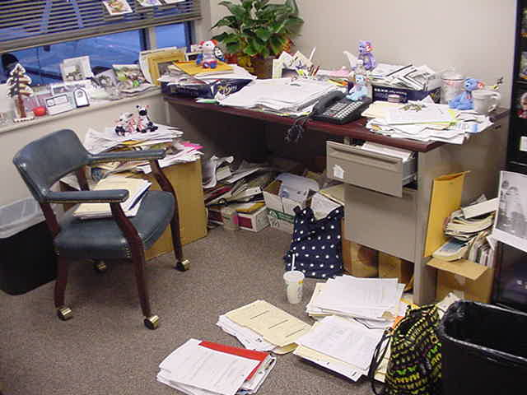

Many offices have a “piling cabinet” as shown below:
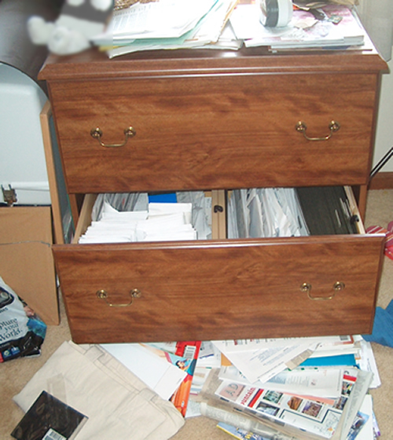

If photos like these are hitting close to home, it is because all of us deal with clutter on one level or another. The question becomes ‘what are you doing about it?’

Office clutter is not about piles of paper, it is about you. To begin the task of eliminating clutter, you must first work on yourself and your feelings. Try to work on how you prioritize your life and your activities. This goes way beyond time management and enters into the realm of human focus.

From a management perspective, organization is a key attribute of good management. To be effective and efficient, you must have the ability to manage your workspace, your files, your computer, your schedule as well as employees, projects, telephone calls and meetings. Having pro-active follow-up procedures to ensure that you get back to people when they need to hear from you is critical. This includes both your employees and clients.

Here are ten sure-fire tips to begin the process of de-cluttering your office and your mind:
- Handle paper as much as possible only once. Deal with paper when it arrives. Don’t pile it up in stacks on the floor so frequently that you cannot tell what color your carpet is. Every piece of paper you receive can be handled by placing it where it goes, not in piles.
- Screen out the unimportant stuff. Often the only important information will be names, numbers, figures, etc. If it is address related, put it into your contact software, rolodex or other means of storage.
- File efficiently. Use a color coded tab system, if paper files, to keep the same information uniformly in every file in the same area. Perhaps the most ignominious of clutter categories is electronic clutter. How sad is it to file something in a folder on your computer or server and then have no idea where you filed it, much less having a way to retrieve it? If filing electronically, mimic the paper files with a similar folder and subfolder system. This way, you do not have to remember two different filing systems. Use a desktop search tool to find things (www.X1.com, for instance). If you file non-compliance, or financial record related material (such as a newspaper article) and then you do not look at it again for a year, throw it out!
- Delegate effectively. You need to develop the skills of knowing when to handle paper yourself versus when to hand it over to someone else to handle. Develop protocols for this and follow them.
- Throw it out. If you receive a paper and you read it, if you do not need it, throw it out. Don’t add it to the ‘pile’ when you know you will never look at it again.
- Recycle. If you feel guilty about throwing papers out, recycle them. Many offices use shredders in-office or hire a shredding service to ensure privacy. Maintain a recycle bin in the office where everyone can contribute.
- Mail. Learn to go through your mail before you put it down. Open it right away. Throw out junk mail now! Divide the remaining mail into folders or inboxes labeled such as: bills, client filing, regulatory, broker/dealer, and/or miscellaneous.
- Sticky notes. Instead of using sticky notes for reminders that should be in your schedule, Personal information manager or CRM software, use sticky notes for things that must be dealt with that day. Put dates or handling instructions on sticky notes attached to piles to accelerate their disposition. You can get these in different colors to denote different levels of priority (how about green, yellow and red).
- Organize: Clean your desk at the end of every day. Walking into an office with a cluttered desk is deflating and de-motivating. It can overwhelm you and leave you frustrated, angry and helpless. And, while we are on subject, don’t buy office supplies you do not need. Many offices carry hundreds of dollars in office supplies that are rarely, if ever used. Most cities offer office supply stores with one day delivery. Do you really need to carry a large “inventory” of office supplies taking up valuable (and expensive) office storage space?
- Plan: Learn to plan your time. Use an organizer, contact and schedule management software or other tools to help you get your time organized. Prioritize your time based on your business plan, your office schedule and your personal life. All too often, a financial advisor’s personal life is put on the back burner in favor of an appointment with a client. While the appointment may be necessary, does it have to conflict with your daughter’s birthday party or your wedding anniversary? Determine priorities in scheduling that allow you to set rule on when and what kind of appointment would violate your personal time.

If you follow these ten tips, you will most likely not only increase your office efficiency, you will also greatly improve your employees’ attitudes, the atmosphere in the office, your clients perception of you and your staff. You may even improve your personal life.

David Lawrence, AIF® (Accredited Investment Fiduciary™) is a practice efficiency consultant and is President of David Lawrence and Associates, a practice-consulting firm based in Lutz, Florida. (www.efficientpractice.com) David Lawrence is a much sought-after public speaker on a variety of leadership, financial and technical topics. For details, visit www.davidlawrencespeaks.com.

