Client Relationships: An Efficient Model
By David L. Lawrence

Financial Advisory firms position themselves for long-term profitability when they embrace the importance of client relationships. Effective relationships help firms find new clients, build client loyalty and increase the value clients receive from that firm. Therefore, strengthening client relationships should not only be a goal of financial advisors, but a top priority. Surprisingly, few actually systematically map out what that relationship should be, much less build an efficient client relationship model.
The importance of building a model lies in the ability to consistently apply the steps in the model across all aspects of a financial advisor’s practice. If an advisor devises such a model and then fails to share it with his/her employees (for instance), then the model is effectively rendered useless.
Much can be learned by studying what the ‘big boys’ do. Large corporations have long embraced a comprehensive approach to client (customer) relationships. Client relationship management (CRM) typically spans all aspects of a corporate business structure from front office to back office and records direct and indirect interactions with clients to build a powerful database that can be used to better manage those same relationships. Key data can be analyzed to plan target-marketing campaigns, build effective business strategies, and weigh the effectiveness of current services based on a variety of criteria and metrics.
Though most financial advisory firms lack the financial resources to match the CRM initiatives of the large corporations, there are still many lessons to be learned and much of what they do can be emulated (albeit on a smaller scale).
Technology considerations should include a well-rounded CRM software program that can capture all relevant information on client data, interactions and historical records. The database should be capable of collecting information about each client and their interactions with the firm, such as appointments, financial data (investments, transactions, risk considerations, estate issues, etc.), personal data (including subtleties such as client interests, children’s activities, etc.), client requests, survey responses and even client use and participation in client offerings (such as client appreciation events, website content usage, etc.).
This data can and should be analyzed to better understand the needs and wants of a firm’s clients from a variety of perspectives. Survey data can often uncover weak areas in client service offerings or overdone service offerings. (i.e. too much paperwork sent to the client). Website usage data can uncover unused features of a website and/or heavy usage of a particular area of the website that might be expanded to meet a need. Ignoring such data could be wasteful, costly and lead to client dissatisfaction. Most website hosting services offer usage data, often broken down into specific areas of the website, to provide useful tools in changing, upgrading, improving and/or deleting content.
Environmental scans provide needed additional information on a financial advisory firms’ service offerings relative to a variety of factors including such things as your client’s opinions, competitors’ services, employee perspectives, and market area demographics. As part of the environmental scan you may wish to consider two ideas for information gathering: 1.) Client focus groups – this would be a one-time session with a broad selection of client groups to discuss the relative merits of current service offerings (everything from quarterly reports, website features, and client meeting content to client communications, etc.); and, 2.) Advisory council (group) – this would be a select group of clients asked to serve on such a council to meet periodically (perhaps once or twice a year) and to be available via email for specific issue discussions relevant to the firm and its clients. As this group could be recognized, either on a letterhead, website or other medium, it could be presented as an appointment of some distinction (attractive to some clients). And, it provides a valuable, ongoing resource to bounce ideas off of.
Ultimately, the purpose of gathering such data for analysis is to build a client relationship model that matches the needs, wants and expectations of the client.
Elements to consider in constructing a relationship model should include:
- Letters – birthday cards, anniversary cards, thanksgiving cards, Correspondence, Confirmations, etc.
- Emails – announcements, information (non-personal), invitations, alerts, requests (such as to contact the office for an appointment, confirmations, etc.
- Phone calls – incoming (live person), outgoing (appointment setups, etc.)
- Face-to-face meetings (quarterly meetings, informal get-togethers, etc.)
- Web 2.0 Functions – when the client visits your website, it ‘pushes’ customized content (such as personalized greeting, user-selectable page content features, menu item choices, etc.)

Letters and emails can prove to be a very powerful way to strengthen relationships with clients by assuring that follow-up communications are timely and reassuring. As an example, a client hands you a check to be invested into a group of investments, per a previous discussion. If an advisor collects the check and then does nothing, chances are the custodian would send out a confirmation to the client. However, this could take several days.
In the meantime, the client is left to worry about whether or not the money was invested timely and correctly. By immediately sending out a confirmation email or letter (acknowledgement), the client is reassured that the investment(s) are being handled professionally and in a timely manner. This is true for most client and/or advisor initiated requests. It is simply a ‘best practice’ to keep the client informed. With advanced client relationship management software, the task is easy and quick. With most software of this type, it can be as simple as a single button click to load an email (or letter) template with personalized client information and send it.
A partial list of these types of communications are:
- Transaction acknowledgements | - Rebalancing notifications
- Appointment reminders | - Beneficiary changes
- Ownership changes | - New client welcome
- Meeting notes – confirmation of decisions | - And many, many more
The so-called Web 2.0 offers the promise for revolutionizing client relationships in a profound and compelling way. By being able to customize content to each client or visitor to your website, you can effectively personalize the look and feel of the website to suit the needs of individual clients. As an example of such technology, consider Amazon (www.amazon.com). Amazon creates a customized page with suggestions for additional purchases when someone views a particular product.
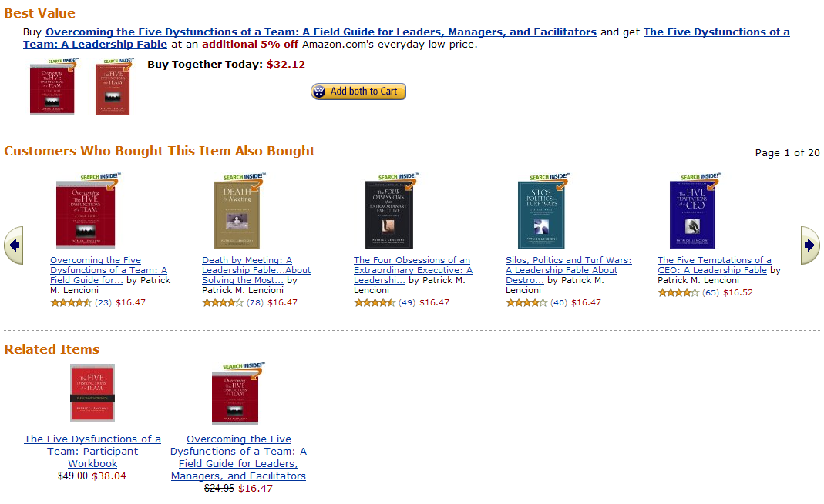
While it is unlikely that a financial advisory firm would tie such web 2.0 content pushing to individual products, a subtle use of this technology might be in recognizing which pages of your website have been visited by a particular client and suggesting a conversation with an advisor on that topic or area of interest, creating an RSS feed suggestion (really simple syndication – a method to push news, information, etc. based on content selection) or a specific invitation to meet with an advisor.
How this kind of personalized content impacts client relationships is through the realization by the client that their situation and needs are being addressed on multiple levels, providing several choices on where and how they wish to receive information and communications. It also distances the firm from a one size fits all approach, by creating compelling personalized visuals that differentiates the firm from its competition.
The financial advisory profession was built on the foundation of phone calls and face-to-face communications. And, even though the profession has moved in the direction of technology, it would be foolish to ignore the power of the spoken word. Ultimately, clients want and need to hear from you, not a recording.
The desired end-result of the client relationship model should be a symbiotic relationship between the advisor and the client. This may be characterized by the recognition of mutual goals, the client to reach certain financial goals and the advisor to fully understand the clients financial situation and needs relative to those goals. And, it can also be characterized by the mutual trust and respect the client and advisor have for each other.

David L. Lawrence is a practice efficiency consultant and is President of David Lawrence and Associates (DLA), a practice-consulting firm based in Tampa, Florida. DLA publishes a monthly subscription newsletter, “The Efficient Practice”, which focuses on operational efficiency. (www.EfficientPractice.com) David is a much sought-after public speaker on a variety of leadership, financial and technical topics. For details, visit www.davidLawrenceSpeaks.com.

