The Efficient Practice

By David L. Lawrence, AIF®

Workflow Revisited

Clearly, one of the hottest topics among financial advisors this year appears to be workflow; and how to get a handle on it. Understanding your office workflow is essential in determining practice profitability. It is also a key tool to use in training, monitoring and evaluating your employees. Yet, it may be the least understood much less utilized aspect of practice operations.

Software developers have done their part to support workflow in the office. Junxure-I (www.junxurei.com) and ProTracker Advantage (www.protracker.com) both have workflow features that permit customizing workflow into groups of tasks associated with a specific type of procedure in the office. Both have suggested lists of tasks that can be used, or you can create your own tasks and groups of tasks.

Junxure-I has Action tasks that permit the user to assign a task with time and date stamping. The task can be general in nature or tied to a client record. The task (or action item) can then show up on the assigned employee’s action list with prompts. Once completed, the assigned employee can indicate so with a date completed. The record is retained in history for anyone who uses the system to see. With custom reports, an administrator could develop a task accountability report to help in specific task completion studies and to oversee and compare similar tasks performed by different people.

ProTracker Advantage has created an extensive library of tasks. Additionally, the software utilizes an employee-scheduling feature in addition to client and other scheduling.

Other programs have task scheduling capabilities, such as Act4Advisors ((http://www.software4advisors.com/act4advisors.htm) that can perform similar functions. Microsoft Outlook 2007 (www.office.microsoft.com), a much-improved version of this venerable software, includes better task integration on the Outlook calendar. Office Outlook 2007 integrates tasks on the calendar into the Daily Task List so that you see them displayed beneath your daily appointments and meetings. To allot time for working on a task, you simply drag the task onto your calendar. When you complete a task on a given day, the task sticks to that day, providing a visual record of the work that you performed. Tasks that you do not complete roll over to the next day, and accumulate until you mark them as complete. Tasks can be viewed in three places, the To-Do bar, in Tasks and on the Calendar. This offers more flexibility and choices than in previous versions.

However, despite these additional features and functions, Client Relationship Management (CRM) Software can only take you so far. Linking your workflow task assignment and history to accountability procedures is a bit more difficult. If you have developed employee position outlines, with specific, objective and measurable activities and behavior, the problem is finding a way to use a workflow system to produce a report that can assess the skill level and competence of the employee in performing any task or group of tasks. Often, CRM software that has workflow features only accumulates task completion details (with date and time). Even though this information is helpful, it does not go far enough to encompass an entire workflow and employee performance comparison. For this, you may need to use divergent software or systems.

KnowlegePoint (www.knowledgepoint.com) has a number of helpful products that can be used to assess employee performance, write employee job descriptions (outlines) and manage personnel. Their Performance Now software can set, track and measure goals and objectives. Completed reviews include editable performance text, ratings, a review summary, development plans and room for employee comments and designated signatures. The software includes competency ratings and performance reminders such as upcoming performance reviews. KnowledgePoint also offers a more comprehensive solution called Performance Impact Workplace.

The advantage of using this type of software is its ease of use and handy features that tie in well with other programs that surround the workflow process. Tying employee performance to a specific workflow requires some additional steps. One, important tool to consider when building a workflow process that consist of several tasks, such as the financial planning process, is to consider writing a flowchart that depicts the process and its various decisions.
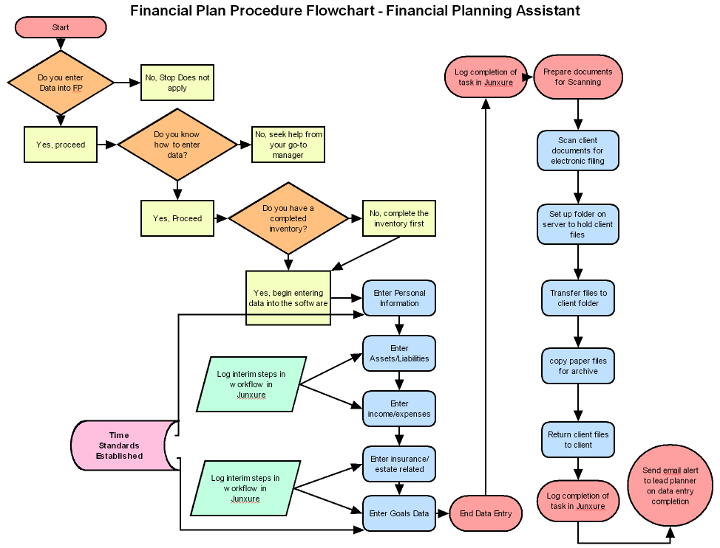
This type of flowchart (as shown in the example above) is often easier for new employees to grasp and aids in training. It also provides a framework for building the tasks associated with this procedure and then evaluating employee performance, based on established time standards and task completion issues (such issues as efficiency and proficiency). The above flowchart was written using SmartDraw (www.smartdraw.com). Recently, SmartDraw announced the addition of 22 new SmartTemplates® designed to help meet the needs of finance and accounting professionals. The software is packaged with hundreds of other templates for all types of business graphics.

Using these tools to develop client profitability reports is also difficult, though some new software, such as Junxure-I version 7.0 (due for release before year-end) and Workflow Plus (www.workflowplus.com), have plans to contain pricing features (such as linking expenses to an action) that should make determining client profitability and firm profitability an easier task.

Workflow should be accompanied by observable activities and behavior. Spending too much time observing employees could label you a micro-manager. Doing so surreptitiously could lead to accusations of employee spying. That is why using technology in partnership with a modest level of personal observations, based on objective criteria established in a position outline, is the more effective and efficient method of completing the workflow management cycle.

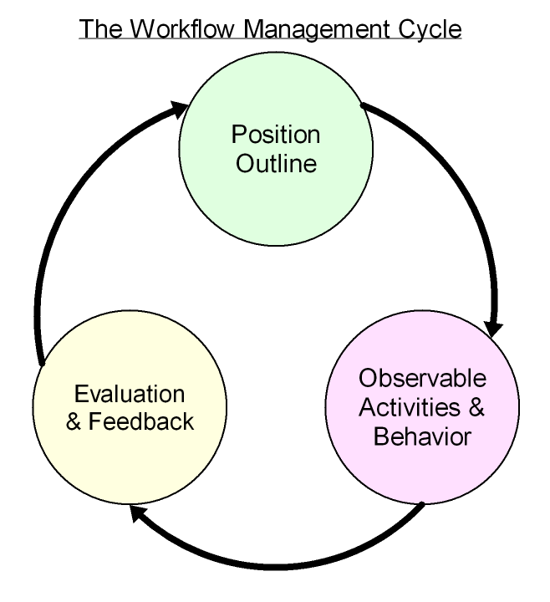
©Copyright 2007 David Lawrence and Associates

Often, simply going through this process leads to additions, deletions, corrections or other enhancements to the position outlines. These outlines should not be static. The process of managing employees using this type of method can lead to a need for changes and updates. It can also uncover training opportunities and reveal the need to document additional procedures. The key to make this work in your firm may be to involve your employees directly in the process. Through inclusion, you can build ownership of workflow procedures within your staff. If an employee has a hand in developing the workflow procedures, they are more likely to “buy-in” to the need to follow strict steps of tasks inside of a workflow group of tasks.

One potential downfall to fully documenting tasks might be pushback or “foot dragging” by an employee who might feel threatened by the process. In this instance, there might be an employee who performs a task in your office that no one else in the office knows how to do. This employee might feel that their position in the firm could be in jeopardy by revealing too much of what they do. It is important to work with this type of employee and point out that by having the ability to fully document tasks, cross training of employees is possible, which increases the value of that employee to the firm (and not the other way around).
Ultimately, developing and using comprehensive workflow management systems can lead to increased efficiency and greater net profit for your firm.

David Lawrence, AIF® (Accredited Investment Fiduciary™) is a practice efficiency consultant and is President of David Lawrence and Associates, a practice-consulting firm based in Lutz, Florida. (www.efficientpractice.com) David Lawrence is a much sought-after public speaker on a variety of leadership, financial and technical topics. For details, visit www.davidlawrencespeaks.com.

