Advanced search and storage solutions

By David L. Lawrence, AIF®

Being a gadget guy has its drawbacks. There are simply too many gadgets out there for one person to own, much less use. Therefore, it is always helpful when information is shared relating to the utility of a particular gadget. And, if the gadget proves to be an efficient tool, so much the better. Such is the case with two software programs, available for free, that are offered as desktop search tools.
The first comes to us from the good people at Yahoo and X1. The enterprise version of its desktop search tool (http://desktop.yahoo.com/) boasts productivity gains through unified, actionable search of desktop files and email without compromising your existing security. As the definitive search experience for business users, X1 changes how knowledge workers store, search, find and take action on information.
X1 Enterprise Client allows you to search and instantly find information on your local PC, preview it in its native format and take action on it immediately. This effectively reduces or eliminates the time that you spend hunting through various applications, email and file folders for information you already know exists. With support for over 300 file types, this software offers lightning fast searches with its user friendly interface which is conveniently placed (minimized) in your system tray. When accessed, the full interface looks like the following:
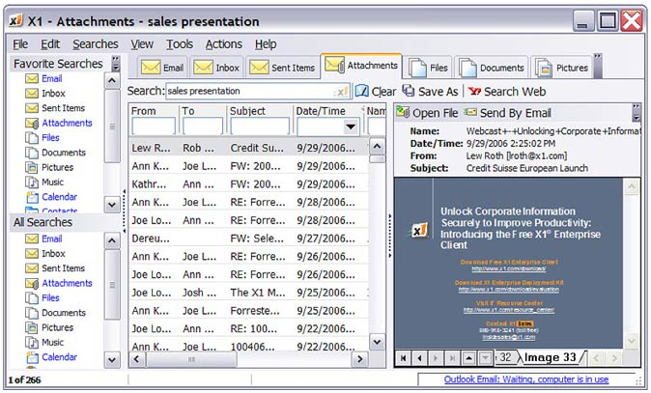
Find information faster and work smarter through powerful search and search refinement capabilities
• Search your entire PC in less than a second
• See search results appear as fast as you type; refine results on the fly by adding more characters or terms
• Use common characters and/or words for search
• Use powerful operators such as Boolean search terms and range search
• Optional toolbar enables even faster searches
• Sort instantly by name, date, document type, size, file location, and more
• Drag and drop search results onto your desktop or into other applications
• Take action on results immediately with program-specific post-search actions - Open, Print, Send by Email, Go to Folder and more
• Copy email messages to PST files for archiving
• Export search results to Excel or other data format
The desktop search tool integrates seamlessly into Microsoft Outlook and/or Lotus Notes. Offering indexing and search tools from within those programs, as well as Eudora, Thunderbird and others.
Google offers a similar product. Google Desktop (http://desktop.google.com/) gives you easy access to information on your computer and from the web. It's a desktop search application that provides full text search over your email, files, music, photos, chats, Gmail, web pages that you've viewed, and more. By making your computer searchable, Google Desktop puts your information easily within your reach and frees you from having to manually organize your files, emails and bookmarks. It makes searching your computer as easy as searching the web with Google.
Google Desktop doesn't just help you search your computer; it also helps you gather new information from the web Sidebar and Google Gadgets, which can be placed anywhere on your desktop to show you new email, weather, stock information, photos, personalized news, RSS/Atom feeds, and more. Sidebar is personalized automatically, without any manual configuration required (though you can certainly make your own customizations if you want to or turn off automatic personalization). Sidebar takes up room on your computer screen, but with added features, such as weather, stock info, email, etc, it offers a more integrated and robust information portal.

And, for those of us who remain panic stricken over increased compliance regulations, There is a cool new tool from Qmobilsoft that records all outgoing and incoming phone calls (and voice memos) for your Treo Smartphone. CallRec 4.0 (http://www.qmobilsoft.net/product.htm) is the premier voice recording application for the Treo smartphones. This simple-to-use application allows you to record your telephone conversation and voice memos with ease by simply pressing the Treo side key. Or, you can set option to automatically record all your phone calls.
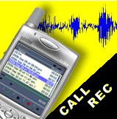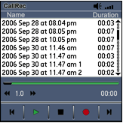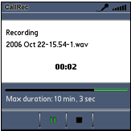
CallRec store files directly to the memory card and recording duration is limited only by free space on the card. With adjustable recording sample rate you can make optimal balance between sound quality and file size. Once activated, the program allows you to commence recording before or during any incoming or outgoing call with a single click. Furthermore, you can configure CallRec to automatically record all your incoming and/or outgoing calls. Share your recording and send your files by IR, Bluetooth or e-mail. At a suggested retail price of $19.99, this is a cost-effective tool for those who wish to add one more layer of protection.

David Lawrence, AIF® (Accredited Investment Fiduciary™) is a practice efficiency consultant and is President of David Lawrence and Associates, a practice-consulting firm based in Lutz, Florida. (www.efficientpractice.com) David Lawrence and Associates offers a variety of consulting services including technology consulting related to the financial planning process and investment management.

